Ruminations on the Massachusetts State House
Here at our sea-washed, sunset gates shall stand/
A mighty woman with a torch, whose flame/Is the imprisoned lightning, and her name/Mother of Exiles. Emma Lazarus. “The New Colossus.” 1893.
 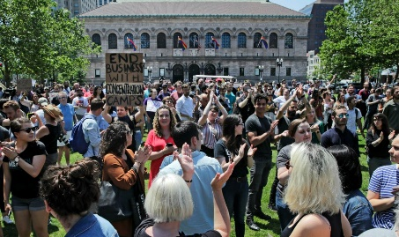 Charles Krupa/AP
Óscar Alberto Martínez Ramírez Copley Square, Boston, June 26, 2019
and his 23-month-old daughter, Valeria, Hundreds of Wayfair employees walked out on the job
drowned trying to cross the Rio Grande. Wednesday after workers discovered the company had sold
(Julia Le Duc/Associated Press) $200,000 worth of furniture to a Texas detention center housing
migrant children. Washington Post June 26, 2019.
Who are we? Who do we want to become? The Mass. State House asks that question by its very existence. Dedicated to the “people,” its grandeur reminds us of the best we can be as a nation-better than any others preceding the founding of this country, a foundation built on the truths we hold to be self-evident that ALL humans are created equal and endowed by their creator with …life, liberty, and the pursuit of happiness. Jefferson left those phrases deliberately vague in his
sublime opening to the Declaration of Independence, most likely because he understood that changing times would bring altered needs. Emma Lazarus’s 1893 sonnet titled “The New Colossus,” and read at the dedication of the Statue of Liberty on Oct 28, 1886, echoed those sentiments:
"Give me your tired, your poor,
Your huddled masses yearning to breathe free,
The wretched refuse of your teeming shore.
Send these, the homeless, tempest-tost to me,
I lift my lamp beside the golden door!"
We have come to a turning point in this nation, one demanding that we take our heads out of our collective social media, the technology that controls us, the Soma* that anesthetizes us, and demand that we become once again the nation that our founding parents envisioned. The millennial workers at Wayfair have decided to do just that. They are the true retainers of Jefferson’s hope for the world. I salute them and you, the true descendants of Jefferson’s promise.
The State House is more than a building. Its grandeur and the care in maintenance and upkeep become a representation of the best that America stands for. The building itself is a reification, a living symbol of who we are as a Common Wealth and as a nation.
What does this have to do with the State House? Everything. Its grandeur, dedication to history, honoring of its citizens, military as well as civilian, remind us of why America became the beacon of hope for the free-and not so free-world. As we traverse this storied structure, as we look at its spaces, its dedications, its working parts, we need to keep those questions in mind. When we do that, only then will we be able to recognize ourselves in the mirror.
*Soma, the drug used by characters in Aldous Huxley's Brave New World, which allowed people to escape from reality by thinking less critically, and which helped government to control them.

